Name:____________________
Lymphatic System Questions ___/25
- Describe the Lymphatic System in your own words.
/2

- What are the general functions of the lymphatic system?
/2

- Describe lymph.
/1

- What is the difference between the thoracic duct and the right lymphatic duct?
/1

- What causes lymph fluid to move through the lymphatic vessels?
/2

- What are the major functions of lymph nodes?
/2

- What function does the spleen play in the lymphatic system?
/1

- What function does the thymus play in the lymphatic system?
/1

- What function do the tonsils play in the lymphatic system?
/1

- What function do the Peyer’s patches play in the lymphatic system?
/1

- What function does the appendix play in the lymphatic system?
/1

- Provide a brief description (one sentence) of each of the following disorders:
Edema:

Metastatic Cancers:
/5
Hodgkin Disease:

Non-Hodgkin Lymphoma:

Ruptured Spleen:

Elephantitis:

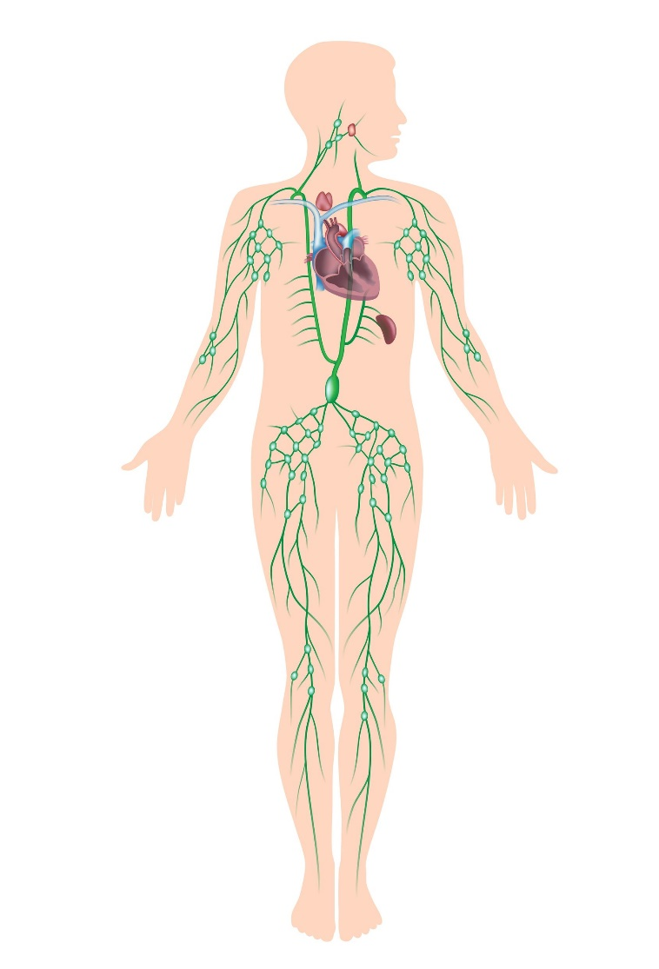
- Label the following structures on the diagram below:
right lymphatic duct, spleen, thoracic lymph duct, thymus, tonsil

/5

